**PROJECT REPORT**

**For**

**AgriConnect-Malawi**

**PROJECT TEAM (GROUP 8)**

|  |  |  |
| --- | --- | --- |
| FIRST NAME | LAST NAME | REGISTRATION NUMBER |
| Patrick | Kamphulusa | BSC/INF/12/19 |
| Shadreck | Khamba | BSC/INF/21/19 |
| Nasiar | Kanswanswa | BSC/PHY/26 /19 |
| Ben | Kaponda | BSC/INF/02/19 |

**Document Version: [2.1]**

**Date: [16/06/2024]**

# 1. TABLE OF CONTENTS

TABLE OF CONTENTS .................................................................................................................1

DOCUMENT INFORMATION ......................................................................................................2

LIST OF ACRONYMS ...................................................................................................................3

INTRODUCTION ...........................................................................................................................1

LIST OF TABLES ...........................................................................................................................4

LIST OF FIGURES .........................................................................................................................5

2 PROJECT DESCRIPTION ...........................................................................................................2

### 2.1 PROBLEM STATEMENT ..................................................................................................2 2.2 SIMILAR PRODUCTS .......................................................................................................2 2.3 UNIQUE VALUE PROPOSITION THET YOUR PRODUCT PROVIDES .....................2

1. KEY REQUIREMENTS FOR THE PRODUCT .........................................................................3
2. TECHNICAL DESCRIPTION OF THE PRODUCT ..................................................................4
3. PROGRESS SCHEDULE ............................................................................................................5
4. PROSPECTS FOR CONTINUED DEVELOPMENT AND COMMERCIALIZATION ...........6
5. ROLES PLAYED BY EACH MEMBER OF THE PROJECT TEAM .......................................7
6. CHALLENGES FACED & MITIGATION .................................................................................7
7. LESSONS LEARNED..................................................................................................................7
8. CONCLUSION ...........................................................................................................................8

# 2.DOCUMENT INFORMATION

*Please document all changes made to this document since initial distribution.*

|  |  |  |  |  |
| --- | --- | --- | --- | --- |
| Date | Version | Author | Section | Amendment |
| 8 May | 1 | Patrick Kamphulusa | Introduction | Initial version of the document |
| 15 May | 2 | Shadreck Khamba | Project  Description | Updated project details and problem statement |
| 22 May | 2 | Nasiar Kanswanswa | Technical Description | Added technical details and  database architecture |
| 29 May | 2 | Ben Kaponda | Progress Schedule | Updated progress schedule and roles |

# 3.LIST OF ACRONYMS

* **MySQL:** My Structured Query Language
* **PHP:** Hypertext Preprocessor
* **V2M:** Vendor to customer
* **IDE:** Integrated Development Environment
* **HTML:** Hypertext Markup Language
* **RDBMS:** Relational Database Management System
* **CSS:** Cascading Style Sheets

## INTRODUCTION

In today's dynamic business landscape, e-commerce stands out as a driving force, fundamentally altering the way transactions occur for goods and services. It represents a shift towards online trading, eliminating geographical barriers and fostering connections between buyers and sellers through virtual marketplaces fuelled by technological advancements and convenience. This transformation has had a profound impact on industries worldwide, empowering both established retail giants and emerging entrepreneurs to flourish in the digital age. In nations such as Malawi, where agriculture serves as a backbone of the economy, there exists immense untapped potential for e-commerce to revolutionize traditional practices. Enter Agriconnect-Malawi, a pioneering ecommerce platform dedicated to catalysing change within Malawi's agricultural sector. Agriconnect-Malawi specializes in a wide range of agricultural products, including farm produce, livestock, agrochemicals, fertilizers, processed goods, and machinery, serving as a vital link between agricultural dealers, farmers, and consumers. This innovative platform simplifies trade processes and enhances market accessibility, allowing agricultural stakeholders from diverse regions of Malawi to showcase their products effortlessly, while enabling buyers from across the nation to make purchases seamlessly. This forward-thinking approach unlocks new avenues of opportunity for all stakeholders, irrespective of their location within Malawi. With the increasing prevalence of smartphone usage and the proliferation of online platforms, Agriconnect-Malawi is poised to lead the charge in reshaping the agricultural landscape, driving sustained growth and prosperity for the sector.

## 4.PROJECT DESCRIPTION

Agriconnect-Malawi stands as a pioneering online platform poised to revolutionize the agricultural trade landscape in Malawi, a nation deeply rooted in agriculture. Malawi's economic prosperity heavily relies on the success of its agricultural sector; however, traditional trading practices often present challenges such as limited market access, and inefficient distribution channels. Addressing these challenges, Agriconnect-Malawi simplifies the trading process and enhances market accessibility for farmers and sellers across various regions of the country. At its core, AgriconnectMalawi's innovation lies in its ability to seamlessly connect agricultural dealers, farmers and sellers with potential buyers. Through its user-friendly interface, the platform empowers farmers to showcase their diverse range of products, spanning from crops like maize, rice, and tobacco to livestock such as cattle, goats, and poultry, as well as agricultural inputs like agrochemicals, fertilizers, and machinery, catering to the comprehensive needs of both smallholder farmers and larger agricultural enterprises. This user-friendly interface not only facilitates product listings but also enables buyers to navigate the platform effortlessly, find the products they need, and make purchases with ease, addressing the significance of accessibility in the Malawian context. Leveraging the rise of smartphone/computer use and increasing online platform penetration in Malawi, Agriconnect-Malawi strategically positions itself to drive growth and prosperity within the agricultural sector by providing farmers with broader market access. Historically, Malawian agricultural dealers and farmers have faced challenges in accessing markets beyond their local communities, limiting opportunities for growth and profitability. Agriconnect-Malawi effectively addresses this issue by serving as a centralized marketplace where farmers can reach buyers from across the country, meaning from different districts promoting market efficiency and benefiting both buyers and sellers alike. Moreover, Agriconnect-Malawi contributes to food security and overall well-being within Malawi by offering consumers a wide variety of agricultural products, essential for meeting the nutritional needs of the population. Therefore Agriconnect-Malawi represents a transformative force in Malawi’s agricultural sector by creating opportunities for growth and prosperity for agricultural dealers, farmers, sellers, and consumers alike, extending its impact beyond being just an online marketplace to drive change and sustainable development in Malawi’s agricultural economy.

1. PROBLEM STATEMENT

In Malawi, the nation heavily relies on agriculture for economic sustenance, faces significant challenges due to traditional trading practices that limit market access and create inefficient distribution channels for farmers and agricultural dealers across various regions and districts. These issues, including limited market access, and fragmented marketplaces hinder economic growth and profitability. The absence of a centralized platform exacerbates these challenges, hindering the efficient exchange of agricultural products and limiting market reach. As a result, despite the nation's agricultural potential, farmers and agricultural dealers struggle to tap into broader markets, while consumers face limited access to a diverse range of agricultural products.

Therefore, there is an urgent need for a transformative solution that can bridge the gap between agricultural producers and consumers, facilitate efficient market access, and foster sustainable development within Malawi’s agricultural economy. Agriconnect-Malawi aims to address these problems by developing an innovative online platform that connects farmers, dealers, and buyers nationwide. This user-friendly platform leverages increasing smartphone and internet use to expand market access, streamline distribution, and centralize agricultural trade, thereby enhancing economic prosperity. By providing a comprehensive marketplace for a diverse range of products, from crops and livestock to agricultural inputs, Agriconnect-Malawi seeks to drive sustainable development, improve market efficiency, and promote the overall growth of the Malawi’s agricultural sector.

1. SIMILAR PRODUCTS

1. AgriMart

AgriMart presents itself as a comprehensive marketplace for agricultural products, boasting a wide range of offerings including agrochemicals, fertilizers, and machinery. Its user-friendly interface and robust features make it a convenient choice for both buyers and sellers. However, limited customization options and a lack of specialized services may hinder its appeal to niche markets and specific agricultural needs and also it does not offer the selling of agricultural produce.

1. AllinOne (Malawi)

Owned by Kondwani Kachamba, AllinOne is a versatile platform designed to serve various sectors in Malawi, not exclusively focusing on agriculture. This platform offers a wide range of services, including an online marketplace that connects buyers and sellers across different industries. While AllinOne supports agricultural trade, its broader scope encompasses other sectors such as retail, services, and manufacturing.

c. UNIQUE VALUE PROPOSITION THAT YOUR PRODUCT PROVIDES

Agriconnect-Malawi sets itself apart with a range of benefits designed specifically for the agricultural needs of Malawi: To begin with, it provides a wide variety of agricultural products, from crops to machinery, creating a marketplace that suits everyone involved. Secondly, it focuses on the specific challenges and opportunities found in Malawi's farming sector, ensuring it meets the needs of local farmers and buyers. Thirdly, it has an easy-to-use interface that's simple for people with different levels of tech skills. Additionally, it breaks down barriers caused by distance, making it easier for farmers to sell to more people and buyers to find what they need. Additionally, you can use it on your phone, which makes it even more convenient for everyone involved

**5. LIST OF TABLES**

# 6. LIST OF FIGURES

1. Use Case
2. Storyboard
3. Overall architecture
4. Component diagram
5. Database architecture
6. Deployment architecture

#### 6.1. Use Case

A use case diagram is a UML design that illustrates the interactions between the AgriConnect-Malawi platform and external entities. It defines and details specific interactions and behaviours of the platform from the perspective of its users, known as 'use cases.' These use cases describe how the platform will be used to achieve specific goals or tasks, serving as a tool to gather requirements and effectively communicate with stakeholders of the AgriConnect-Malawi platform. Here are the common use cases of the AgriConnect-Malawi platform:

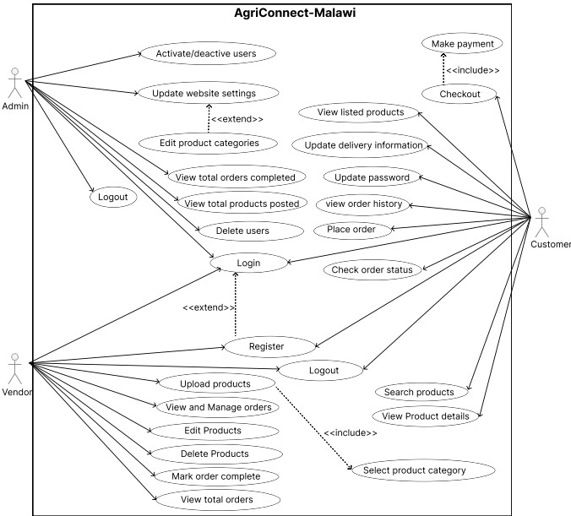

1. **Admin Use Cases**

* + Activate/deactivate users: Admins can enable or disable user accounts.
  + Update website settings: Admins can modify the website’s configuration and settings.
  + Edit product categories: Admins can add, modify, or delete categories under which products are listed.
  + View total orders completed: Admins can see a summary of all completed orders.
  + View total products posted: Admins can view the total number of products listed on the website.
  + Delete users: Admins can remove users from the system.
  + Login: Admins can log into the system to access their functionalities.
  + Register: Admins can create an account on the platform.
  + Logout: Admins can log out of the system.

1. **Vendors (Farmers/Agricultural dealers) Use Cases**

* + Upload products: Vendors can list new products on the website.
  + View and Manage orders: Vendors can see all orders placed for their products and manage them.
  + Edit Products: Vendors can modify details of their listed products.
  + Delete Products: Vendors can remove products from their listings.
  + Mark order complete: Vendors can mark an order as completed once it has been fulfilled.
  + View total orders: Vendors can view a summary of all orders placed for their products.
  + Login: Vendors can log into the system to access their functionalities.
  + Register: Vendors can create an account on the platform.
  + Logout: Vendors can log out of the system.

1. **Customer Use Cases**

* + Make payment: Customers can make payments for their orders. This use case includes the checkout process.
  + View listed products: Customers can browse through the products listed on the website.
  + Update delivery information: Customers can provide or update their delivery details for orders.
  + Update password: Customers can change their account password.
  + View order history: Customers can see a history of all their past orders.
  + Place order: Customers can order products from the website.
  + Check order status: Customers can track the status of their orders.
  + Search products: Customers can search for specific products on the website.
  + View Product details: Customers can view detailed information about a product.
  + Select product category: Customers can browse products by selecting different categories.
  + Login: Customers can log into the system to access their functionalities.
  + Register: Customers can create an account on the platform.
  + Logout: Customers can log out of the system.

**Relationships**

1. **Include relationships** (indicated by dashed arrows):

* + - **Checkout** includes making payment.
    - **View Product details** includes selecting product category.

2. **Extend relationships** (indicated by arrows with a <<extend>> label):

* + - **Register** is extended by Admin and Vendor.
    - **Update website settings** is extended by Admin.

#### 6.2. Storyboard

This section includes the storyboard that visually depicts essential user scenarios and interactions within the Agriconnect Market Platform. The storyboard serves as a visual representation of how various users, including farmers, agricultural dealer’s consumers, and administrators, engage with the platform in specific situations. The purpose of this storyboard is to provide a deeper understanding of the user experience and to facilitate the planning and preparation for different use cases. They aid in visualizing and analysing the platform’s functionality, ensuring it meets the needs and expectations of all users. The following are the storyboards of Agriconnect Market Platform:

##### 6.2.1. Personal 1 scenarios (vendor (farmer/agricultural dealers))

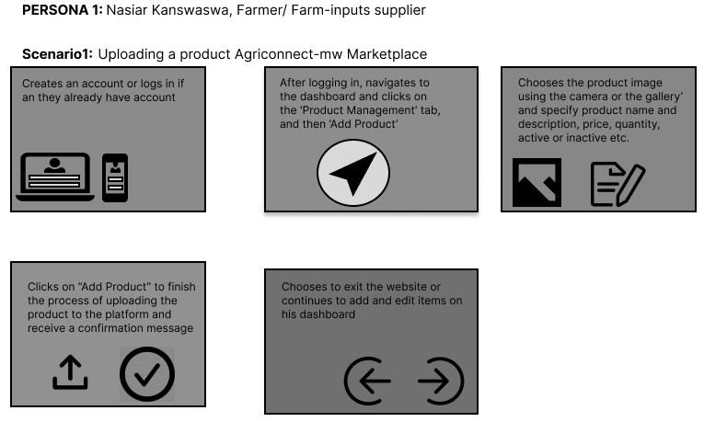

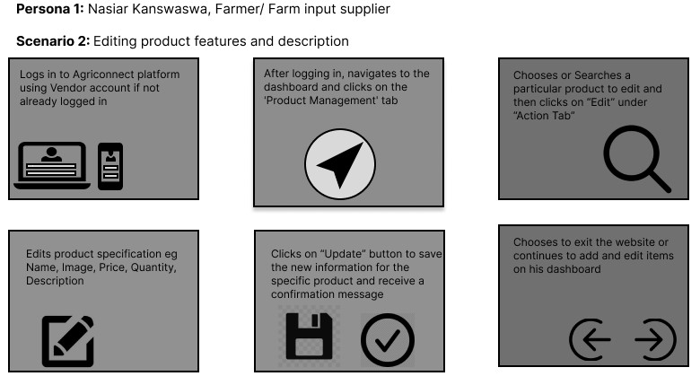

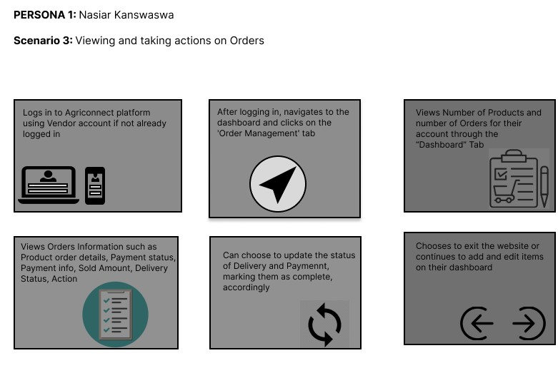

##### 6.2.2. Persona 2 scenarios (Consumer/Customer)

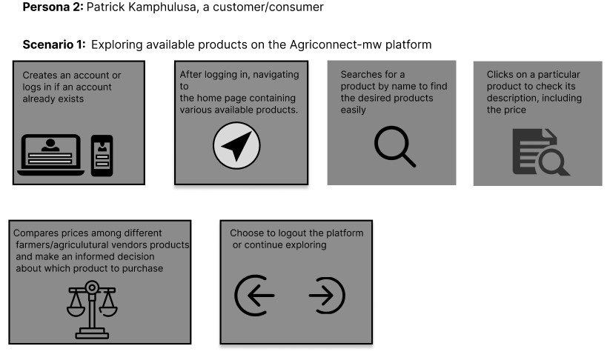

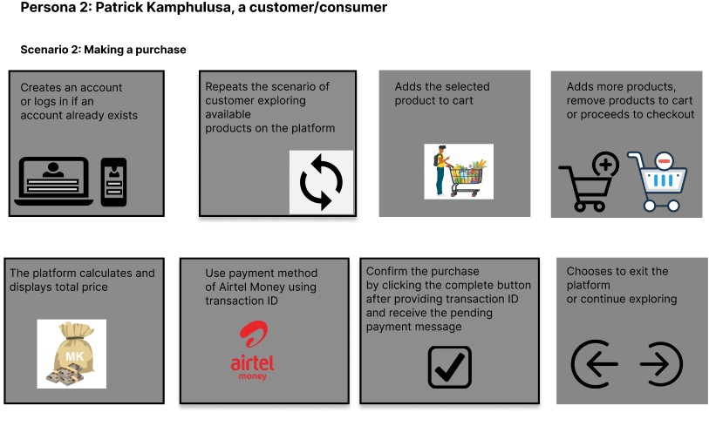

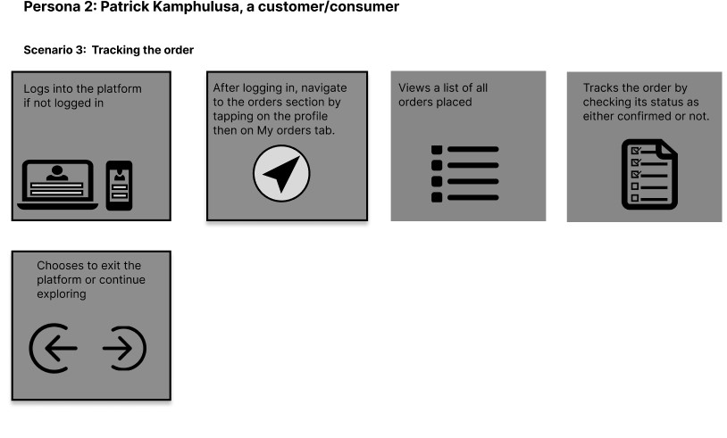

##### 6.2.3. Personal 3 scenarios (Admin)

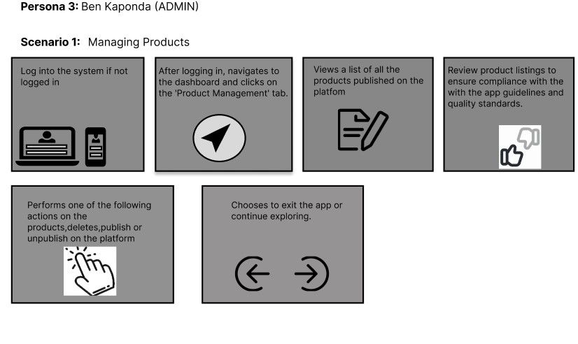

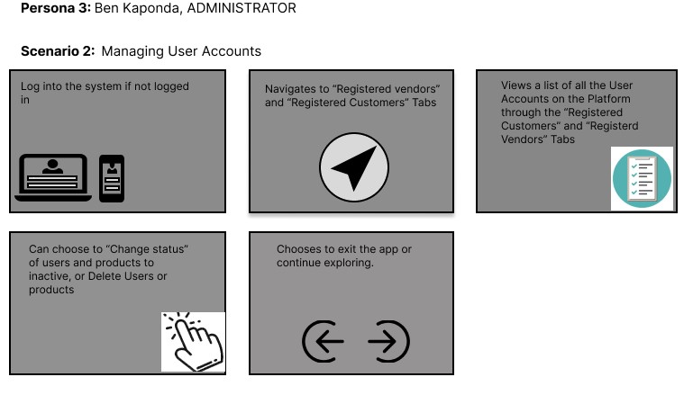

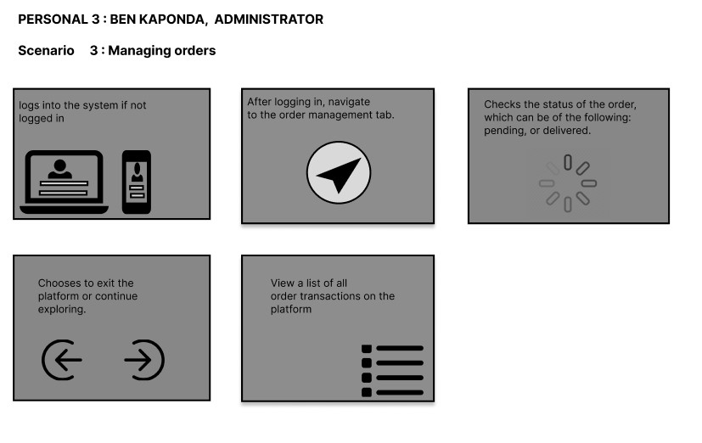

### 7. KEY REQUIREMENTS FOR THE PRODUCT

a. FUCTIONAL REQUIREMENTS

1. **User Registration and Authentication**

This feature allows users, including farmers, agricultural dealers, and buyers, to create accounts on the Agriconnect platform. Users should be able to create accounts and log in securely.

1. **Product Listing and Management**

Farmers and agricultural dealers to list their products on the platform for sale. They can manage their product listings, update them, and provide detailed descriptions to attract buyers.

Consumers should be able to browse and search for products for purchase.

1. **Search and Filtering**

Users can easily search for specific agricultural products using keywords or filters such as category. This functionality helps buyers find products that meet their specific requirements quickly and efficiently.

1. **Online Ordering and Purchasing**

Agriconnect facilitates online ordering and purchasing, allowing buyers to add products to their cart, proceed to checkout, and make payments.

1. **Order Management**

Once an order is placed, both buyers and sellers can track the status of their orders through the Agriconnect platform. Farmers and agricultural dealers should receive and manage orders.

1. **Payment Processing: Transaction References**

As customers opt to pay using bank transfers, transaction information will be provided on the Agriconnect platform for reference. This includes details such as transaction description, ID, ensuring transparency.

1. **Mobile Responsiveness**

The Agriconnect platform is designed to be mobile-responsive, ensuring that users can access its features and services from various devices, including smartphones and tablets. This ensures accessibility and convenience for users who prefer to use mobile devices.

1. **Updating Delivery Information**

Allows customers to modify or update their delivery details as needed, ensuring accuracy and flexibility in the delivery process.

1. **User Management**

Admin should be able to block, unblock, and delete user accounts.

b. NON-FUCTIONAL REQUIREMENTS

1. **Security**

The system implements robust authentication and authorization mechanisms to ensure that only authorized users can access required functionalities like checking out.

1. **Usability**

The platform should be intuitive and easy to use, with clear navigation, and user-friendly interfaces.

1. **Scalability**

The system should be able to handle an increasing number of users with time.

1. **Performance**

The platform should be highly responsive, with fast loading times and minimal latency.

1. **Reliability**

The system should handle errors gracefully and provide meaningful error messages to users.

1. **Device Compatibility**

The platform should have a responsive design that adjusts to various screen sizes and resolutions, providing a user-friendly experience on desktops, laptops, tablets, and smartphones.

1. **Browser Compatibility**

The platform should work seamlessly on all major web browsers, including Google Chrome, Mozilla Firefox, Safari, Microsoft Edge, and Opera.

### 8. TECHNICAL DESCRIPTION OF THE PRODUCT

#### 8.1 Overall architecture

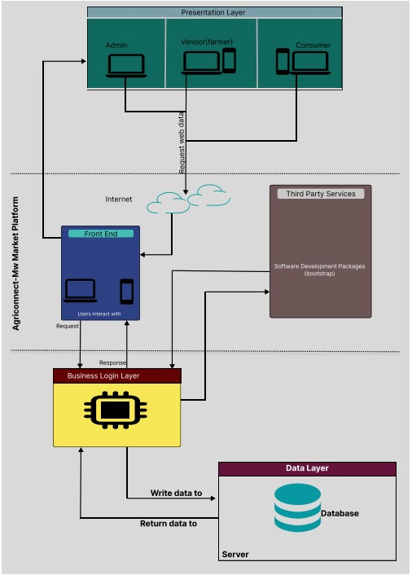

**User Roles:**

* **Admin**: Manages the overall system, including user accounts, and system configurations.
* **Vendor**: Agricultural product sellers and dealers who list their products on the platform. They manage pricing, and order fulfilment.
* **Consumer**: Buyers who browse, select, and purchase agricultural products listed on the platform.

**Presentation Layer:**

* **Front End**: The user interface where Admins, Vendors, and Consumers interact with the system. This layer handles all user interactions and displays information from the server.
* **Request Web Data**: Users send requests through the front end to retrieve or manipulate data.

**Business Logic Layer:**

* Server: Processes requests from the front end, applying business rules and logic to ensure correct data manipulation and retrieval.
* Request and Response Handling: Manages the flow of information between the front end and the data layer. Ensures that data requested by users is fetched from the database and returned appropriately.

**Data Layer:**

* **Database**: Stores all data relevant to the platform, including user information, product listings, transaction details, and more.
* **Write Data To**: Saves new or updated information to the database.
* **Return Data To**: Fetches data from the database in response to user requests.

**Third Party Services:**

* **Software Development Packages**: Utilizes external libraries, frameworks, and tools to aid in the development and maintenance of the platform. These packages enhance functionality, security, and performance. Examples of such packages include:

▪ **Bootstrap**: A front-end framework for developing responsive and mobilefirst websites, providing pre-designed components and styles.

**Flow of Interaction:**

1. Users (Admin, Vendor (farmers, agricultural dealers), and Consumer) interact with the Front End through web browsers on mobile phones or computers.
2. The Front End sends requests for data or actions to the Server.
3. The Server processes these requests based on business logic, interacting with the Database to retrieve or store data.
4. The Database responds with the required data or confirms that the data has been written successfully.
5. The Server sends a response back to the Front End, which updates the user interface accordingly.
6. Third Party Services (like software development packages) are called as needed to enhance functionality, security, and performance.

#### 8.2 Component diagram

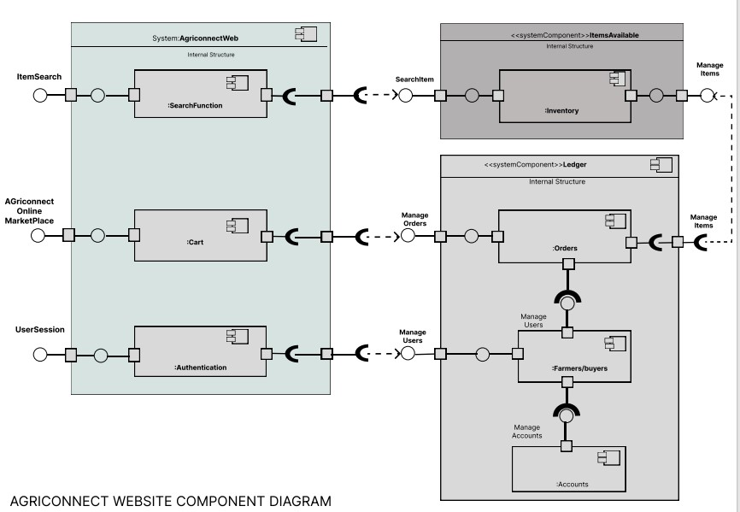

The Agriconnect Web system is designed to facilitate interactions between farmers and buyers, managing all related processes from search and cart management to user authentication and transaction information record-keeping. The system is composed of various components, each serving a specific function to ensure a seamless and efficient user experience.

**Components and Their Responsibilities** 1. **SearchFunction**

* Handles all search-related activities within the system.
* Process search queries from users.
* Retrieve and display relevant results based on search criteria. ➢ Optimize search algorithms for accuracy and speed.

1. **Cart**
   * Manages the shopping cart for users. ➢ Responsibilities:
     + Add items to the cart.
     + Update quantities or remove items from the cart.
     + Calculate total costs.
     + Save cart state for users across sessions.
2. **Authentication**
   * Manages user authentication processes. ➢ Responsibilities:
     + Handle user login and logout processes.
     + Manage session information and user states.
     + Ensure secure authentication mechanisms (e.g., password hashing, multifactor authentication).
     + Provide functionality for user registration and password recovery.
3. **Ledger**
   * Manages all financial records and transactions within the system. ➢ Subcomponents:
     + - Accounts
       - Manages individual accounts of users.
       - Responsibilities:
       - Track financial details of each user.
       - Farmers/Buyers
       - Manages profiles and interactions of farmers and buyers.
       - Responsibilities:
       - Store and update profile information.
       - Handle order and transaction history between users.
       - Orders
       - Process and track orders made through the system.
       - Responsibilities:
       - Manage order creation, and order confirmation.
       - Track order status from initiation to delivery. ▪ Handle payments, invoicing, and refunds.

**Interaction between Components**

* **SearchFunction** interacts with the **Cart** by allowing users to add items to their cart directly from the search results.
* **Cart** communicates with the **Ledger** to update and process payments when a purchase is made.
* **Authentication** ensures that only authorized users can access their cart, and order history.
* **Ledger** components (Accounts, Farmers/Buyers, Orders) are tightly integrated to ensure that any transaction or update in one area is reflected across the system for accuracy and consistency.

**Data Flow**

The data flow in the application works as follows: First, a user searches for products and the search function retrieves relevant results. The user then adds items from the search results to their cart. Next, the user logs in to proceed with the purchase. The cart sends order details to the orders system, which processes the order. The accounts system updates the user's payment information and ensures the seller's profile reflects the transaction. Finally, the orders system tracks the order status and provides updates to the customer.

**Security and Error Handling**

* **Authentication** ensures secure access through encryption and secure session management.
* **Error Handling** mechanisms are implemented at each component level to handle failures gracefully, providing informative messages.

#### 8.3 Database architecture

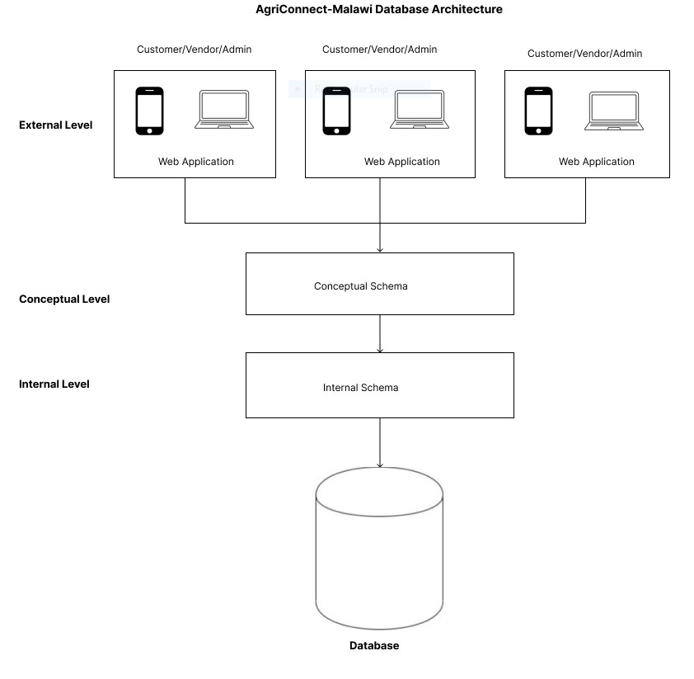

1. **Users and Web Application Interaction (External Level)**

**Users**:

* + **Customer**: End-users who browse products, place orders, and make payments.
  + **Vendor**: Sellers who list and manage their products.
  + **Admin**: System administrators who oversee platform operations, order management, and user management.

**Interaction**:

* + **Customers** interact with the web application to view products, search for specific items, and add products to their cart, place orders, and track order status.
  + **Vendors** use the web application to upload new product listings, update product information, and manage orders.
  + **Admins** manage user accounts, oversee transactions, and monitor platform activity.

1. **Web Application and Conceptual Schema Interaction (Conceptual Level)**

**Web Application**:

* + Acts as the intermediary between users and the database, handling user requests and displaying information retrieved from the database.

**Conceptual Schema**:

* + Represents the abstract structure of the database, managing the organization of data and defining the relationships among various entities without specifying how data is physically stored.

**Interaction**:

* + The web application sends queries to the conceptual schema to fetch data, such as retrieving product details, user profiles, or order history.
  + When a user performs actions (e.g., placing an order), the web application updates the conceptual schema to reflect these changes.
  + The conceptual schema ensures that the data is consistently organized and related, simplifying the retrieval and manipulation of information by the web application. **3. Conceptual Schema and Internal Schema Interaction (Internal Level)**

**Conceptual Schema**:

* + The logical representation of the entire database. It includes entities, relationships, and constraints that define how data is organized and linked.

**Internal Schema**:

* + Represents the physical storage of data in the AgriConnect database. It details how data is actually stored, indexed, and managed on disk, including tables, indexes, and data files. **Interaction**:
  + The conceptual schema translates user actions into database operations that the internal schema executes. For instance, a query to retrieve a list of products is processed by the internal schema to fetch data from storage and return it to the conceptual schema.
  + The internal schema handles the low-level operations, such as reading from or writing to storage, optimizing data retrieval, and maintaining data integrity and performance. • Data from the internal schema is mapped to the conceptual schema’s structure, ensuring that the logical organization matches the physical storage.

**The Flow of Interaction**

The interaction flow in the web application involves several steps: users (customers, vendors, and admins) log in, with their credentials verified against the user database. Customers can browse products, with the application querying the product database to show listings based on user inputs. When customers place orders, the application records order details and ensures data consistency, while vendors can add or update product listings, which are then stored and managed in the product database. Admins handle user account management, with changes reflected in the user database. The web application communicates with the database to retrieve and update data, ensuring logical consistency and proper storage through the conceptual and internal schemas. The internal schema handles data storage, indexing, backups, recovery, and security, ensuring efficient data retrieval and protection.

##### 8.4 Technologies used

###### • Integrated Development Environment (IDE)

– Visual Studio Code: Visual Studio Code was utilized for web application development offering a versatile code editor for web-based platforms.

###### • Programming languages and frameworks

* **JavaScript**: JavaScript was chosen as the programming language for adding interactivity and dynamic behaviour to web pages. It also allows tasks such as form validation.
* **PHP**: PHP was used for tasks such as processing form data submitted by users, managing user authentication and authorization, retrieving and storing information in databases, and generating dynamic HTML content to be displayed in the user's browser.

* **HTML**: HTML as the standard mark-up language was used to create the structure and content of web pages.

* **CSS**: CSS as a style sheet language was used for describing the presentation of HTML elements on a web page. It controls the layout, appearance, and formatting of elements, including their colours, fonts, spacing, and positioning.

* **Bootstrap**: Bootstrap as a front-end framework for building responsive and mobilefirst websites and web applications. It provides a collection of pre-designed templates, CSS styles, and JavaScript components that can be easily customized and integrated into the projects.

###### • MYSQL Database

– MySQL serves as the backend database management system in our web application architecture, responsible for storing and organizing the data that powers our application, encompassing user accounts, product details, orders, preferences, and other essential data. Operating as a relational database management system (RDBMS), MySQL structures data into tables with rows and columns, facilitating efficient storage and retrieval. Each table corresponds to a specific data type, with columns defining the attributes or properties of that data, ensuring an organized and scalable approach to managing our application's information.

###### • Version Control

– GitHub: GitHub was employed for version control and collaborative development. It enabled team members to work on the project simultaneously and manage code revisions.

##### 8.5 Deployment architecture

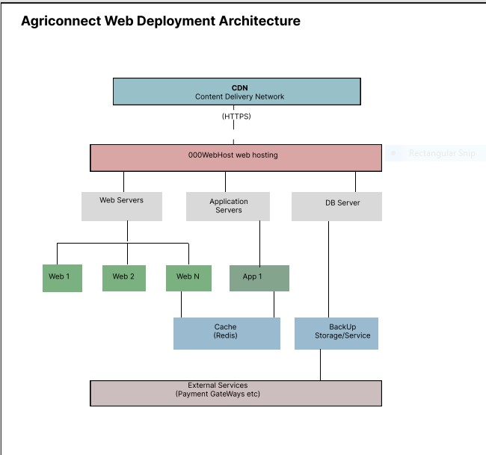

The architecture of the agricultural marketplace web application, Agriconnect, is designed to ensure high availability, scalability, performance, and reliability by leveraging various components and services. A Content Delivery Network (CDN) efficiently delivers static content by caching resources on geographically distributed servers, enhancing loading speed, reducing latency, and providing additional security features like DDoS protection. The web hosting service, 000WebHost, provides the necessary infrastructure, including servers, storage, and network capabilities, to host the application and make it accessible over the internet. Multiple web servers handle incoming HTTP/HTTPS requests, distributing traffic to balance the load and ensure high availability through redundancy. Application servers execute the business logic, processing requests from web servers and interacting with the database servers, which manage data storage and retrieval. Redis serves as a caching layer to store frequently accessed data in memory, optimizing performance by reducing latency. Backup storage/services provide regular backups and facilitate data recovery in case of data loss.

##### 8.6 Code Documentation (should be system generated and should be provided in a separate document)

The code documentation has been provided in the separate file and attached with this document together with other documents.

**8.7 Link to GIT repository**

<https://github.com/shadreckkhamba/Agriconnect_Project.git>

### 9 PROGRESS SCHEDULE

The Progress schedule has been provided in separate excel file that was provided, and attached together with this document and other documents.

### 10 PROSPECTS FOR CONTINUED DEVELOPMENT AND COMMERCIALIZATION

**10.1 What is required to further develop the product/service?**

To further develop Agriconnect-Malawi and enhance its functionalities, we will focus on the following key areas need to be addressed:

1. **Technical Enhancements:**
   * + **Mobile Application Development:** Developing a dedicated mobile application to complement the web platform, ensuring accessibility for users on the go.
     + **Scalability and Performance:** Improve the platform's scalability to handle increased user traffic and ensure smooth performance even during peak times.
     + **Security Features:** Enhance security measures to protect user data and transactions, including advanced encryption, two-factor authentication, and regular security audits.
     + **AI and Machine Learning Integration:** Implement AI and machine learning to provide personalized recommendations for buyers and sellers, optimize pricing, and demand and supply trends.
2. **User Experience Improvements:**
   * + **User Interface Design:** Continuously refining the user interface to enhance usability and ensure a seamless experience for all users.
     + **Multilingual Support:** Introducing support for multiple languages to cater to a diverse user base across different regions of Malawi.
     + **Customer Support:** Establishing a robust customer support system, including live chat, FAQs, and comprehensive user guides to assist users in navigating our platform.
3. **Market Expansion:**
   * + **Geographic Expansion:** Explore opportunities to expand the platform's reach to neighbouring countries, leveraging the success in Malawi as a model for regional growth.
     + **Partnerships and Collaborations:** Forge partnerships with local agricultural organizations in Malawi, cooperatives, and government bodies to strengthen our platform's credibility and reach.
4. **Marketing and Awareness:**
   * **Marketing Campaigns:** Launching a targeted marketing campaigns to increase awareness and attract more users to the platform.
   * **Educational Initiatives:** Conducting workshops and training sessions for farmers and agricultural dealers to educate them on using the platform effectively.
5. **Continuous Feedback and Improvement:**

* **User Feedback Mechanism:** Implement a robust feedback mechanism to gather user insights and continuously improve the platform based on user needs and preferences.
* **Regular Updates:** Ensure the platform undergoes regular updates to incorporate new features, fix bugs, and enhance overall functionality.

*10.2* **What are the commercialization prospects for your product?**

1. **Revenue Generation:**
   * **Subscription Fees:** Introducing subscription plans for special features, offering enhanced visibility, detailed analytics, and marketing tools for vendors and farmers.
   * **Transaction Fees:** Implementing a small commission fee on each transaction conducted through the platform to generate steady revenue.
   * **Advertising:** Allow third-party advertisements on the platform, providing an additional revenue stream.
2. **Market Penetration:**
   * **Growing User Base:** Leveraging the increasing penetration of smartphones and internet usage here in Malawi to attract a large user base, including smallholder farmers, agricultural dealers, and consumers.
   * **Geographic Expansion:** Expanding the platform’s reach beyond Malawi, targeting other countries in the region with similar agricultural landscapes and challenges.
3. **Value-Added Services:**
   * **Logistics and Delivery:** Partnering with logistics companies to offer integrated delivery services, making it easier for buyers to receive their purchases.
4. **Sustainability and Social Impact:**
   * **Empowering Farmers:** Empowering smallholder farmers and agro-dealers by providing them with broader market access, thus improving their income and livelihoods.
5. **Competitive Advantage:**
   * + **First-Mover Advantage:** As a pioneering platform in Malawi’s agricultural sector, Agriconnect-Mw can establish a strong brand presence and loyalty among users.
     + **Unique Value Proposition:** Emphasizing the platform's unique features such as a comprehensive product range, user-friendly interface, and market efficiency to stand out in the market.

### 11 ROLES PLAYED BY EACH MEMBER OF THE PROJECT TEAM

Each member of our project team brought specialized skills and responsibilities that contributed to the development of Agriconnect platform. The team members and their roles are as follows:

1. **Shadreck Khamba**

**Role**: Project Manager

**Responsibilities**:

* + Project Planning and Coordination: Developed the project plan, outlined the scope, and set clear project goals. Coordinated tasks among team members to ensure alignment with the project timeline.
  + Resource Management: Allocated resources effectively, managing the project budget and ensuring the team had the necessary tools and support.
  + Issue Resolution: Facilitated problem-solving sessions to address any obstacles that could hinder project progress, ensuring quick resolution to keep the project on track.

1. **Patrick Kamphulusa Role**: Lead Developer

**Responsibilities**:

* + Feature Implementation: Led the development of core features and functionalities.
  + Technical Problem Solving: Addressed complex technical issues and implemented solutions to overcome challenges encountered during development.

1. **Ben Kaponda**

**Role**: Quality Assurance (QA) Specialist

**Responsibilities**:

* + **Test Plan** Development: Created comprehensive test plans and test cases based on project requirements to ensure thorough testing coverage.
  + Manual Testing: Executed manual tests for various features to streamline the testing process and increase efficiency.
  + Performance and Load Testing: Performed performance and load testing to ensure the platform could handle expected user traffic and usage patterns.

1. **Nasiar Kanswaswa Role**: UI/UX Designer

**Responsibilities**:

* + User Research and Analysis: Conducted user research to understand user needs, preferences, and pain points, using the insights to inform design decisions.
  + Visual Design: Developed the visual design of the platform, including colour schemes, ensuring a cohesive and attractive user interface.
  + Responsive Design: Ensured the platform's design was responsive and provided a seamless user experience across different devices and screen sizes.

### 12 CHALLENGES FACED & MITIGATION

**12.1. What are the key challenges you encountered and what measures did you employ to address the challenges?**

As Agriconnect-Malawi team, we encountered several key challenges related to the development of the platform. Here’s how we addressed them:

1. **Integrating Multiple Features:**
   * **Challenge:** Combining various functionalities such as product listings, user management, payment integration, into a cohesive platform was complex. • **Mitigation Measures:**
     + **Modular Design:** We adopted a modular design approach, allowing us to develop and test each feature independently before integrating them.
     + **Third-Party Services:** We utilized third-party APIs and services for certain features to save development time and ensure reliability.
2. **User-Friendly Design:**
   * **Challenge:** Designing an intuitive and user-friendly interface that caters to users with varying levels of digital literacy. • **Mitigation Measures:**
     + **Simplified Interfaces:** Created simple and clear interfaces with easy navigation to enhance user experience.
     + **Feedback Loop:** Established a feedback loop with users to continuously refine and improve the interface.
3. **Limited Technical Expertise:**

* **Challenge**: Incorporating a payment method into our platform posed significant challenges during integration.
* **Mitigation**: We employed the use of Airtel money payment by using transaction Id as evidence for payment.

**12.2 What challenges remain unresolved?**

**i. Integrating with payment services**

Integrating with payment services like PayPal was a challenge as such it remain unsolved and we used Airtel money transaction IDs as alternative.

### 13 LESSONS LEARNED

Developing Agriconnect-Malawi as part of our final year project has been a profound learning experience. Some of the key lessons we learned throughout the project:

**The Importance of Planning and Project Management:**

* **Lesson:** Proper planning and effective project management are crucial for the successful completion of any project.
* **Experience:** We realized the significance of setting clear goals, creating detailed project timelines, and using project management tools to track progress and ensure timely completion of tasks.

**Collaboration and Teamwork:**

* **Lesson:** Successful projects are often the result of strong collaboration and teamwork.
* **Experience:** Working closely with our team members, leveraging each person's strengths, and maintaining open communication channels helped us overcome challenges and achieve our objectives.

**Technical Skill Development:**

* **Lesson:** Continuous learning and skill development are essential in the field of web development and system architecture.
* **Experience:** Engaging in online courses, seeking mentorship, and learning through hands-on experience significantly enhanced our technical capabilities.

**Adaptability and Flexibility:**

* **Lesson:** Being adaptable and flexible is key to navigating the dynamic nature of project development.
* **Experience:** We learned to adapt our plans and strategies in response to feedback, technical challenges, and changing requirements, ensuring continuous progress and improvement.

**Real-World Problem Solving:**

* **Lesson:** Developing practical solutions to real-world problems requires a deep understanding of the issues and a creative approach to addressing them.
* **Experience:** Understanding the challenges faced by Malawian farmers and agricultural dealers allowed us to design a platform that effectively addresses their needs and promotes market accessibility.

### 14 CONCLUSION

Agriconnect-mw represents a pivotal innovation in the agricultural sector of Malawi, providing a much-needed solution to the longstanding challenges of limited market access and inefficient distribution channels. By offering a centralized online marketplace, the platform empowers farmers and agricultural dealers to connect with a wider audience, facilitating the exchange of a diverse range of products, including crops, livestock, and agricultural inputs. This increased market accessibility not only enhances economic opportunities for farmers but also contributes to food security by providing consumers with better access to essential agricultural products. The user-friendly design and mobile accessibility of Agriconnect-mw ensure that even those with limited digital literacy can participate in this modernized trading ecosystem, thereby driving inclusive growth and fostering sustainable development within the agricultural sector.

Throughout the development of Agriconnect-mw, the team overcame numerous technical and logistical challenges, demonstrating resilience and adaptability. Leveraging supervision, collaborative development, and iterative design processes, we were able to build this platform capable of scaling to meet increasing demands. While some planned features, such as other payment methods, and advanced security measures, remain on the development roadmap, the current version of Agriconnect-mw lays a strong foundation for future enhancements. The lessons learned from this project underscore the importance of planning, teamwork, and continuous learning.